VIRTUAL Early Literacy Event  Wednesday, February 1, 2023  Birth to 3: 10-10:30 AM  Age 3 to 5: 5-5:45 PM  Join us for our Virtual event for children who are Deaf or Hard of Hearing, from birth to age 5, and their families  *Reading the book:  (Birth to 3) (Age 3-5)  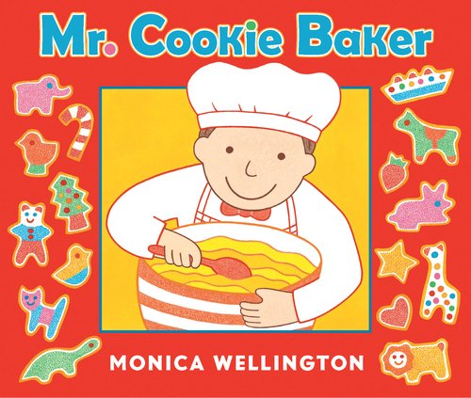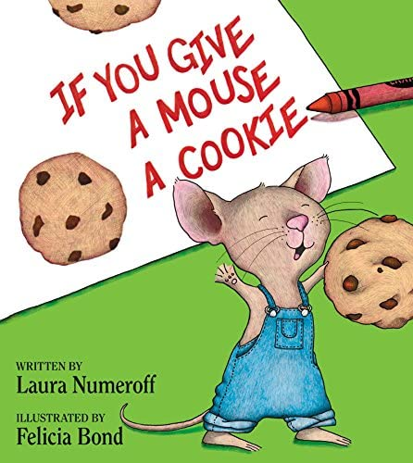  (Families who attend the event will receive a mailed copy of the book)  RSVP: Tuesday, January 31, 2023  RSVP Link: https://bit.ly/FebCookies  Contact: Kim Parra at Kparra@csdb.org  Co-Leads: Kim Parra & Elaine Kim McCarty | Storytelling  ────  Music and Movement  _____  Fun Activities  ────  ASL and Spoken Language  ────  Family Education  Colorado School for the Deaf and the bLIND  33 N Institute St.  Colorado Springs, CO  80903  719-578-2100  www.csdb.org  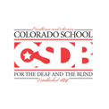  P.R.I.D.E.

