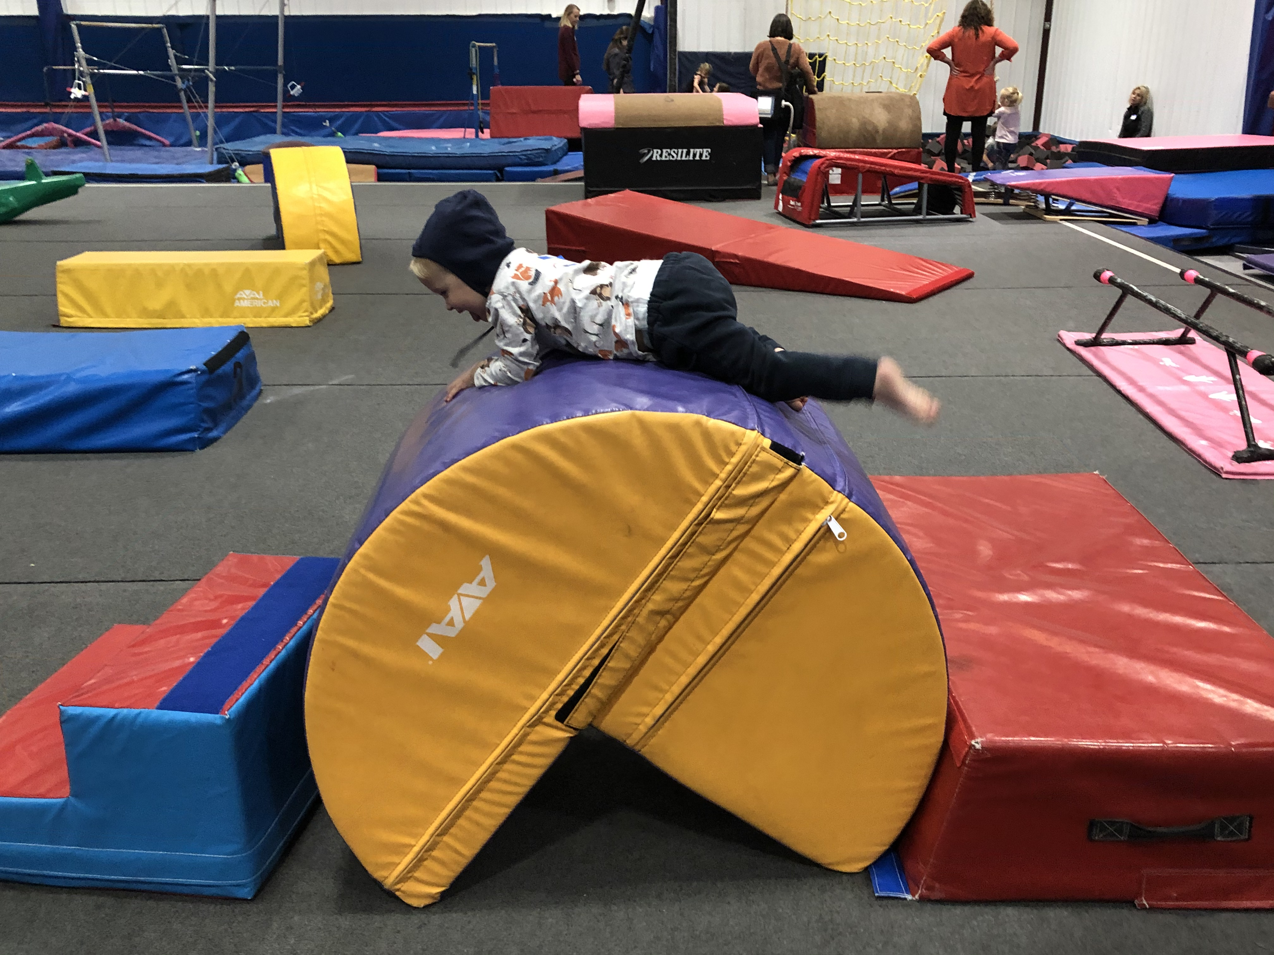  North Colorado Early Literacy Event  Saturday, February 4, 2023  10AM-12PM  Gymstarz Elite  5636 Weld County Road 46  Johnstown, CO 80534  Join us for our North Colorado event for children who are Deaf or Hard of Hearing, from birth to age 5, and their families  *Reading the book:  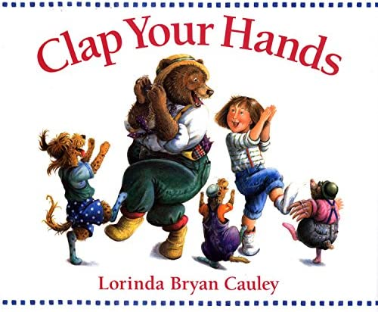  RSVP: Thursday, February 2, 2023  RSVP Link:  Contact: Kelly Doolittle at kdoolittle@csdb.org  Co-Leads: Kelly Doolittle & Cathy Noble-Hornsby | Storytelling  ────  Music and Movement  ────  Open Gym  ────  Fun Activities  ────  ASL and Spoken Language  ────  Family Education  Colorado School for the Deaf and the bLIND  33 N Institute St.  Colorado Springs, CO  80903  719-578-2100  www.csdb.org  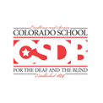  P.R.I.D.E.

