PIKES PEAK Early Literacy Event  Wednesday, February 8, 2023  5-7 PM  Pikes Peak Library District: East Library  5550 N Union Blvd Colorado Springs CO 80918  Join us for our Pikes Peak event for children who are Deaf or Hard of Hearing, from birth to age 5, and their families  *Reading the book:  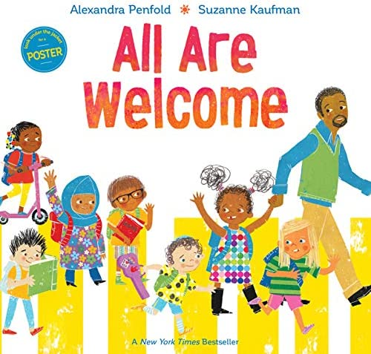  (Families who attend the event will receive a mailed copy of the book)  RSVP: Monday, February 6, 2023  RSVP Link: https://bit.ly/PPELFeb82023  Contact: Jennifer McLellan at jmclellan@csdb.org  Co-Leads: Jennifer McLellan and Jill Cimino | Storytelling  ────  Music and Movement  ────  Children Area  ────  Fun Activities  ────  ASL and Spoken Language  ────  Family Education  Colorado School for the Deaf and the bLIND  33 N Institute St.  Colorado Springs, CO  80903  719-578-2100  www.csdb.org  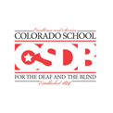  P.R.I.D.E.

