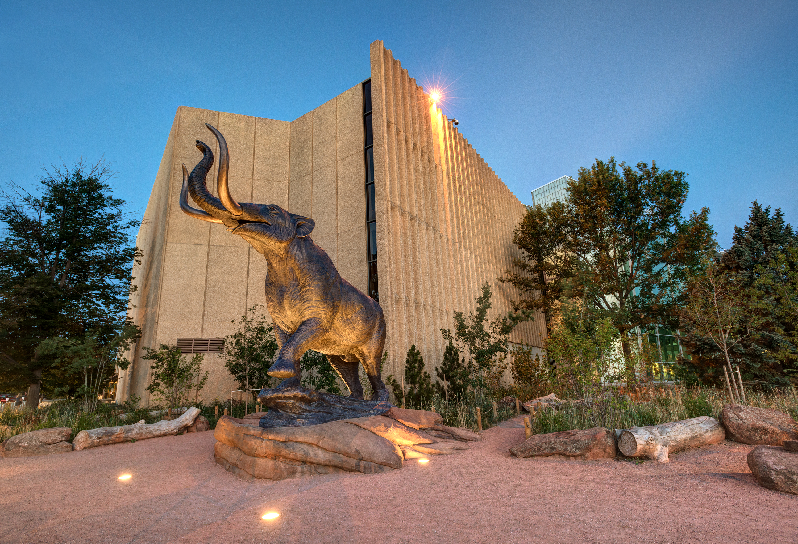  Denver Early Literacy Event  Saturday, February 11, 2023  9AM-11AM  Private use of Discovery Zone from 9-10AM  (Meet at front desk by 9AM punctual)  Denver Museum of Nature and Science  2001 Colorado Blvd. Denver, CO 80205  Join us for our Denver Metro event for children who are Deaf or Hard  of Hearing, from birth to age 5, and their families  *Reading the book:  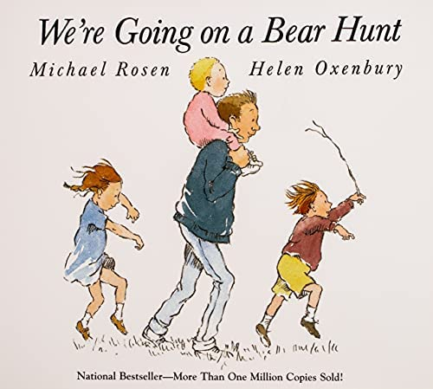  RSVP: Thursday, January 26, 2023  (Museum needs to know in advance)  RSVP Link: https://bit.ly/DenverMuseumNatureScienceFeb11  Contact: Robin Getz at rlgetz@csdb.org  Co-Leads: Robin Getz & Kathy Sevier | Storytelling  ────  Explore the Museum  ______  Fun Activities  ────  ASL and Spoken Language  ______  Free Admission for immediate families  _______  General Admission for  extended families  ────  Colorado School for the Deaf and the bLIND  33 N Institute St.  Colorado Springs, CO  80903  719-578-2100  www.csdb.org  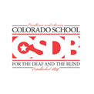P.R.I.D.E.

