2023 Summer at the Parks | - Adams & Jefferson counties  - •  - DHH Littles
Date Time Location – google map link  May 24 9 – 10:30 am Villages East Park - Reunion area  May 31 9 – 10:30 am Carpenter Park * #  June 7 4 – 5:30 pm Westminster Center Park - Peter Pan Park *  June 28 9 – 10:30 am Ralston Park - Central Park *  July 12 9 – 10:30 am Carmichael Park #  Kirsten Gardzelewski, CO-Hear, will join us on June 28  *Splash pad/water area. Consider bringing a bathing suit and towel.  #Wheelchair accessible park | 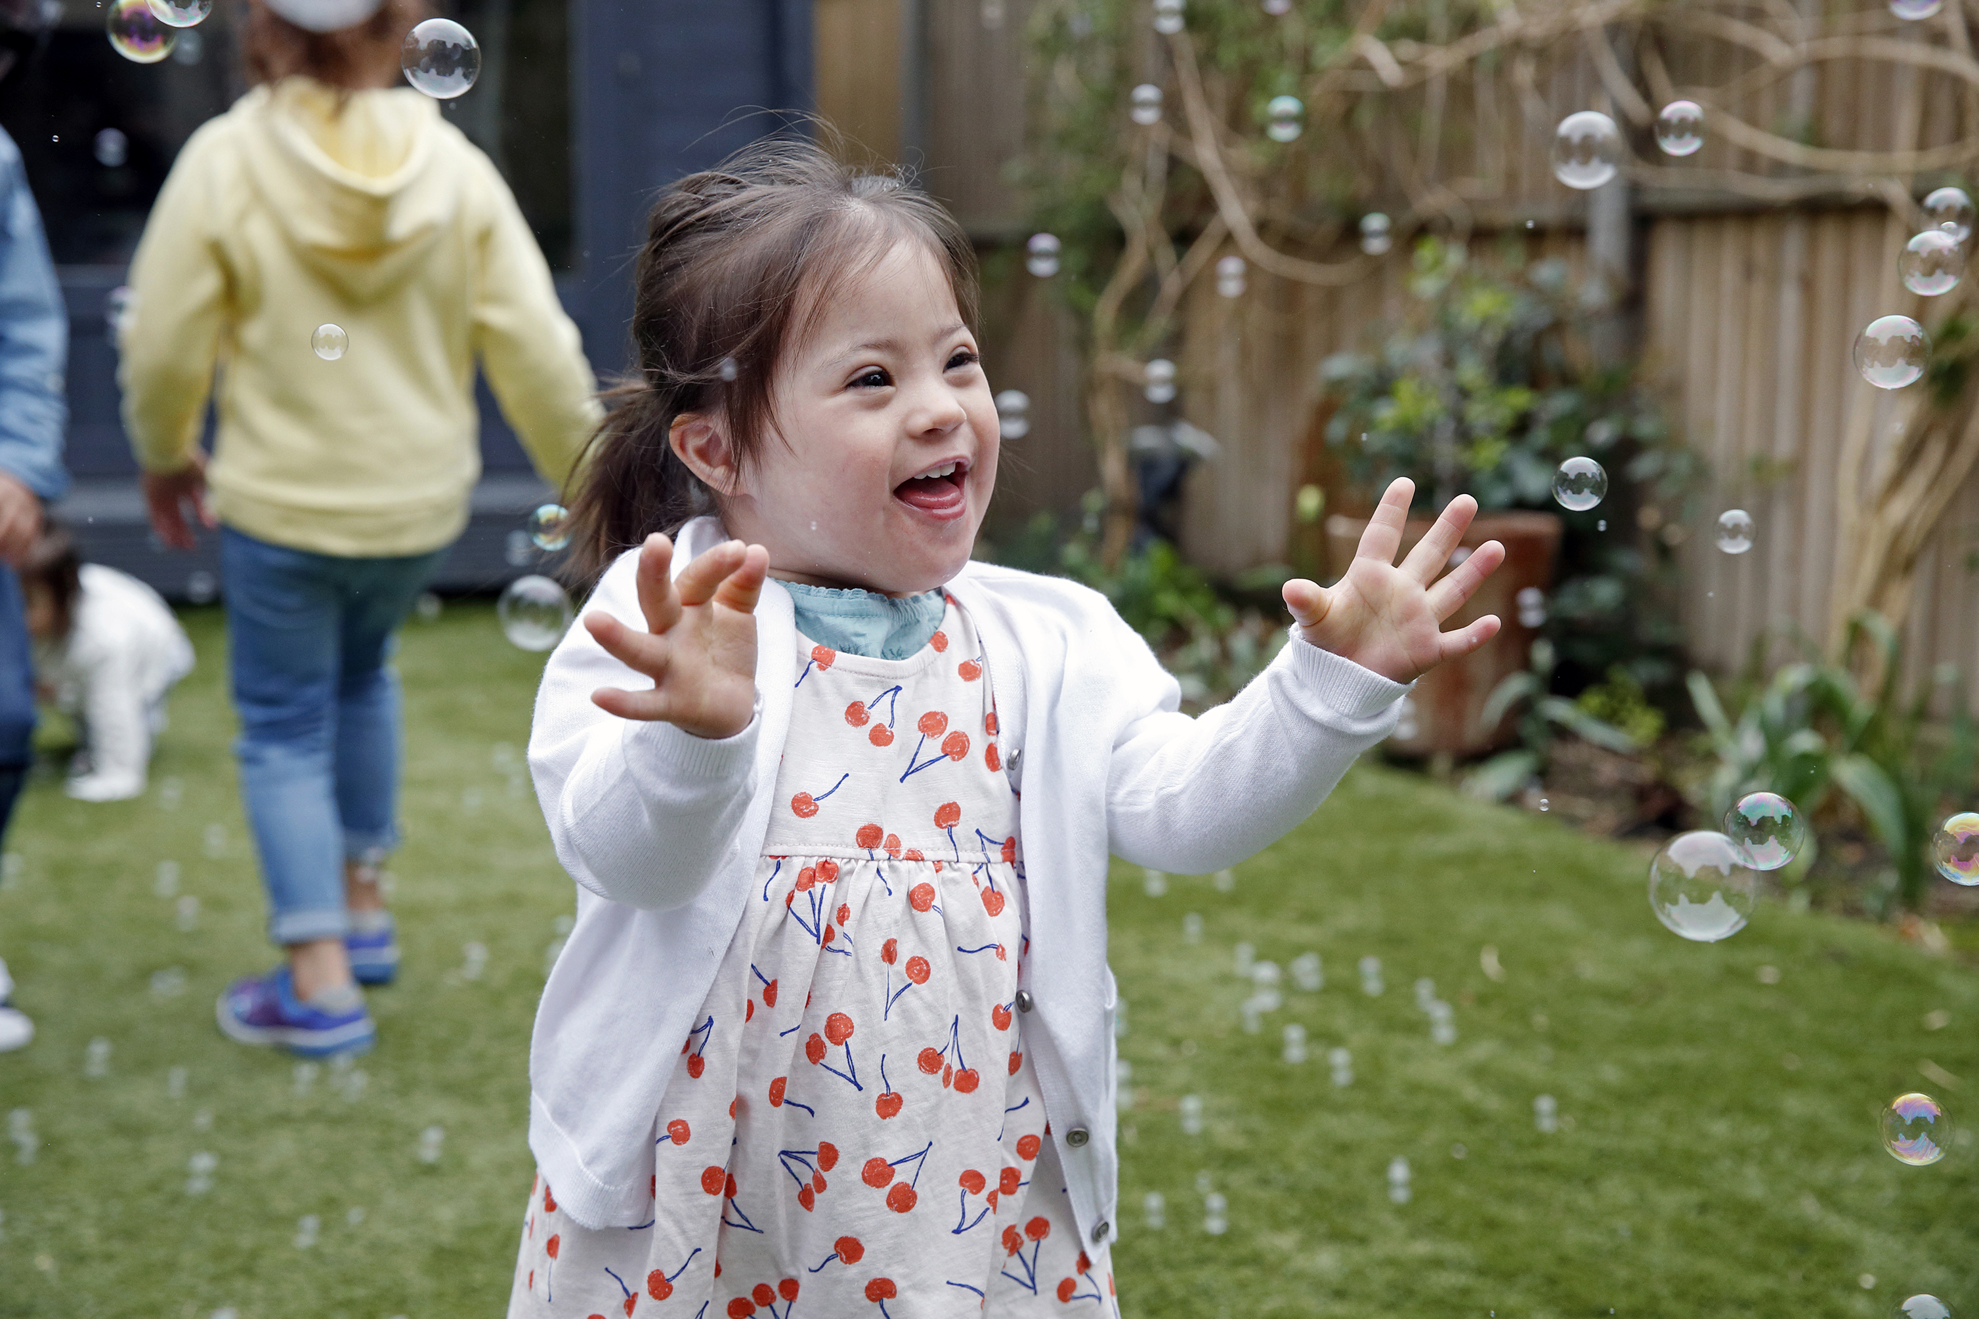  Join Us!  Summers are for being OUTSIDE! Look for the red balloons. Bring your water, snacks, hat, sunscreen and come to play!  Questions, contact Elaine Kim McCarty at 970-218-0342  or ekimmccarty@csdb.org  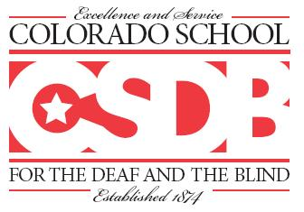  Colorado School for the Deaf and the Blind  33 N. Institute Street  Colorado Springs, CO 80903 www.csdb.org 719-578-2100

