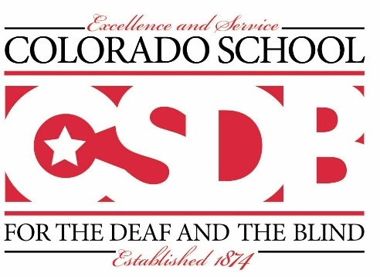
CSDB Accountability
Advisory Committee Agenda

Date: 11/3/2021
Time 4:00pm-5:00pm
Lions Building
Welcome: David Holder
Introductions: David Holder
School for the Deaf/School for the Blind- School Year 2021-2022 Unified Improvement Plan review -Program Principals.

Program Highlights - School for the Blind, School for the Deaf, Student Life-

Upcoming Events
Adjournment: David Holder

Tel: 719-578-2100 Fax: 719-578-2239 CSDB website: www.csdb.org

