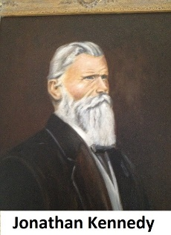
CSDB: Celebrating 150 Years!
On April 8, 1874, seven students sat in a classroom in a house in downtown Colorado Springs eagerly anticipating their first day at a new school, founded by Jonathan Kennedy.

That year, the Colorado Territorial Assembly passed an act to start a school for students who were deaf in Colorado Springs. It was originally called the Institute for the Education of Mutes. The Colorado Springs Company, belonging to General Palmer, donated 10 acres of land on Kiowa Street, and the Territorial Assembly granted $5,000 for a building.

But everyone wanted classes to start right way, so a temporary school was set up in a rented house. By the end of the first year, there were 13 students and 3 staff members.

That first year, Major Henry McAllister, a colleague of General Palmer, donated a printing press. This allowed students to learn the printing trade by creating a newspaper. The first issue of The Deaf-Mute Index was printed on January 30, 1875. Later, the name changed to the Colorado Index. This is how we’ve learned so much about the history of the school.

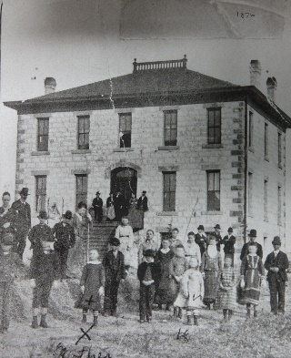
In 1876, the new three-story building was ready. It had 12 rooms with coal stoves and kerosene lamps. There were 20 students and part of the middle floor was set aside for classrooms. The campus had vegetable gardens, as well as a cow and a flock of 50 chickens who provided all the milk and eggs for the school.
Students and staff around original building

In 1877, the name changed to “Institute for the Education of Mutes and Blind” and discussions began about how to recruit, teach, and house students who were blind as well as those who were deaf.

When classes began on Sept. 12, 1883, there were four new students who were blind, and shortly thereafter six more joined.

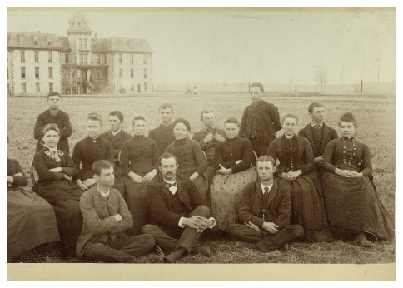
A momentous occasion for the school took place on June 4, 1889, when three students, who were deaf, David H. Wolpert, Grace E. Young, and Paul D. Hubbard became the first graduates.

Shortly after graduation, Paul Hubbard went to the National Deaf College, later Gallaudet University. He joined the football team and as quarterback is believed to have been the creator of the football huddle. Paul got the idea when he noticed players from the opposing team could see him signing the next play to his teammates. To prevent this, he called the team into a tight circle to give instructions. This method was adopted by other teams and eventually became common practice.
Paul Hubbard, first row, first man on the left

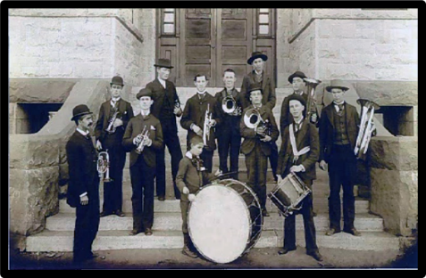
While core subjects continued to be important, there was also an emphasis on students learning a trade. In 1893, carpentry, shoemaking, printing, cabinetmaking, broom-making, mattress-making, and chair seating were options for the boys. Girls could learn dressmaking, needlework, hammock weaving, knitting, beadwork, and baking.
Eclipse Coronet Boys Band-1890

Students who were deaf might also have art lessons, while music was an important skill taught to students who were blind.

For years, school leaders had requested a change in the name of the institute. It was important to them that it was clearly labeled a school, rather than an institution or asylum. The name officially became Colorado School for the Deaf and the Blind in 1895.

A year later, Hugh McCabe, Thomas Kavanagh, and Henry Ralston became the first three students who were blind to graduate.
By 1903, students went to classes for five hours in the morning and worked in their trades for two hours every afternoon. New trades included gardening, dairying, painting, and rug weaving. All students studied standard school subjects. Students who were deaf had either manual or oral classes and students who were blind used the New York Point System,8 a tactile reading and writing system created in the 1860s. Although braille was invented in 1824, it wasn’t used here yet.
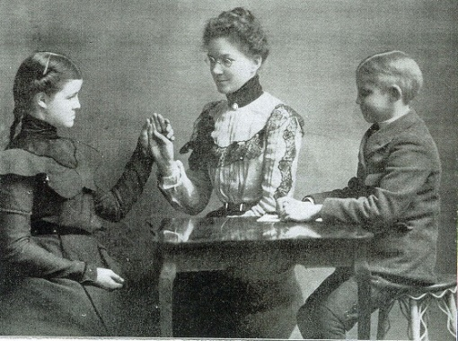
As evidence that CSDB was at the forefront in education, in 1904, 17-year-old Lottie Sullivan, the first student who was DeafBlind, Ralph Wooten, and their teacher, Bessie Veditz, participated in the St. Louis World’s Fair. For over two months, they demonstrated teaching methods for DeafBlind students in the education building and won gold medals.
Lottie, left, Mrs. Veditz, center, Ralph, right
The famous silent horror film star Lon Chaney, the grandson of founder Jonathan Kennedy, was hearing and communicated with his deaf parents using sign language. This skill was credited with Chaney’s acting talent. He went on to be known in Hollywood as “the man of a thousand faces.” While Chaney is immortalized on film, his grandparents’ legacy can be seen today atop Kiowa Street Hill.
In the 1940’s, several new extracurricular activities were added including cheerleading and wrestling for students who were blind. Yearly gymnastics programs highlighted student skills, which they’d learned in gym class. Dr. Brown taught square dancing to students who were Deaf, while students who were blind played music for the dances.
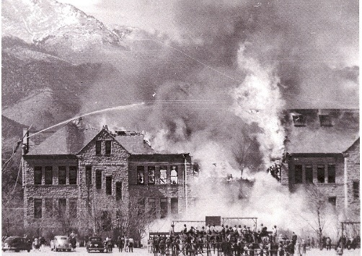
On March 22, 1950, 18-year-old Juan Cruz was enjoying recess outside with other students who were blind when he saw smoke rising from the school building. Juan, along with a couple of other boys, set off the fire alarms and began alerting students. Alumnus Frank Cancino, a teenager at the time, remembers Juan banging a gong to alert everyone. Thanks to regular fire drills, students calmly exited the building, then lined up outside.
Old School Building burns while firemen use water in hoses. Pikes Peak in the background

When they looked back, the building was on fire. Students remember several boys going back inside to rescue paintings from the building. In horror, students stood nearby to watch, until an explosion drove them further away. About a dozen fire trucks from across the city assisted, but the fire spread too quickly, and the building was lost. In addition, the school’s braille library and musical instruments were all destroyed. Frank Cancino remembers seeing the organ crash from the third floor to the basement. “I remember it was heartbreaking, just so much destruction.” It was later determined that an electrical short caused the blaze. Classes were held all around campus until the Gottlieb Building opened in 1952.
In 1968, the first preschool for students who are Deaf began. The program was led by the Junior League of Colorado Springs two mornings a week, serving 10 students the first year. CSDB also began to offer multi-day workshops for preschool-age students and their parents during the summer and community ASL classes.
At the start of the 1969 school year, the Adams Building opened. The new building for students who are blind had nine classrooms, a music room, an auditorium, and a library. Each desk had an outlet to plug in tape and record players, to play recordings of individual lessons.
In 1971, track, football, and basketball star Gary Washington competed in the junior Olympics in track. He was honored at the White House by President Nixon with the “Most Courageous Athlete” award. In 1973, Gary went to the Deaflympics in Sweden where he won three gold and one silver medal in track events. He went on to play football at CU Boulder. In his final game, he had a 72-yard run for a touchdown. He was carried off the field on his teammates’ shoulders with a standing ovation from fans.
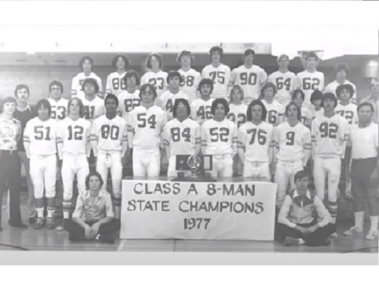
With Gary Washington as running back, the football team had been Black Forest League champions twice. It wasn’t until 1977, however, that they went to the State Championship.
Tim Elstad, class of 1978, remembers playing football every afternoon with his friends long before he was old enough to play for CSDB. By 1977, his senior year in high school, he was the quarterback for an undefeated team which went on to the State Championship game against Simla, which CSDB won, 22-16.
In 1990, the Outreach Program began serving families with students who were Deaf/Hard of Hearing or Blind/Low vision across the state who did not attend CSDB. The program helped school districts, provided opportunities to meet Deaf or blind role models, and offered diagnostic services, library items, adaptive technology, and social activities for young students and teens. Originally based in Denver, the Colorado Instructional Materials Center moved to campus as part of the Outreach Program in 1991.
Goalball, a sport for the blind/visually impaired, was introduced to CSDB students in 1982, and became a school sport. Soon, CSDB was represented on Team USA in Paralympic Goalball. Team USA won the Silver Medal in Athens in 2004 and the Gold Medal in Beijing in 2008.
in 1997, thirteen students were the first to enroll in an on-campus transition program that included independent-living dorms, career development, and the opportunity to attend classes at Pikes Peak Community College. This later became the Bridges to Life Program.
The Deaf Academic Bowl began at Gallaudet University in 1996 as a regional competition. In 2004, the CSDB team qualified for the National Championship. Nine teams competed in the finals that year, and in colorful Hawaiian shirts CSDB came out victorious.
In 2020, the Covid-19 pandemic caused the school to close for a period and then remote learning began. Staff helped deliver devices to students’ homes across the state and dorm staff and teachers created activity videos for students to follow. That fall, a hybrid learning model began with some students in-person and others tuning in via Zoom. Various social distancing and mask policies were in place for much of 2021, until later in the year when safety precautions were lifted.
Now, as CSDB celebrates 150 years and we look back on the resiliency, ingenuity, and legacy of those who came before us, it is our turn to write the next part of this story.

