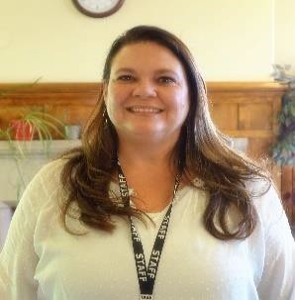 | Kelly Doolittle | C: 719-640-9084  F: 970-703-8221  kdoolittle@csdb.org | Boulder Morgan  Cheyenne Phillips  Kit Carson Sedgwick  Larimer Washington  Lincoln Weld  Logan Yuma
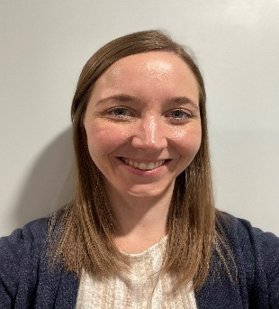 | Sarah Mullervy | O: 719-578-2254  F: 719-578-2139  smullervy@csdb.org | Garfield Mesa
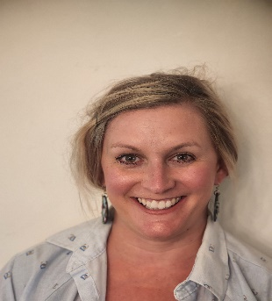 | Jill Cimino | C: 719-641-5138  F: 719-578-2139  jcimino@csdb.org | Baca Huerfano  Bent Kiowa  Chafee Las Animas  Crowley Otero  Custer Prowers  El Paso Pueblo  Fremont Teller
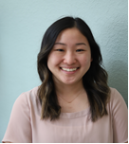 | Elaine Kim McCarty | C: 970-218-0342  F: 719-578-2139  ekimmccarty@csdb.org | Adams Broomfield
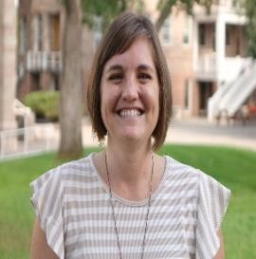 | Kirsten Gardzelewski | C: 719- 641-3988  F: 719-578-2139  kgardzelewski@csdb.org | Clear Creek Moffat  Eagle Park  Gilpin Pitkin  Grand Rio Blanco  Jackson Routt  Jefferson Summit  Lake
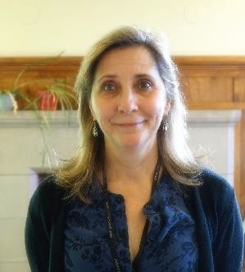 | Lynn Wismann | C: 720-413-7429  F: 720-489-9335  lwismann@csdb.org | Arapahoe (except Aurora)  Douglas  Elbert
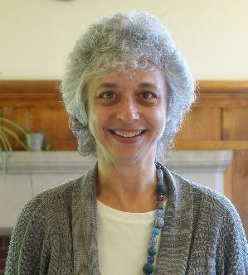 | Robin Getz | C: 720-413-7426 v/text  F: 719-578-2139  rlgetz@csdb.org | Denver  Aurora
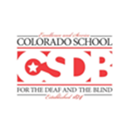 | Kelly Doolittle  Jill Cimino |  | Alamosa Mineral  Archuleta Montezuma  Conejos Montrose  Costilla Ouray  Delta Rio Grande  Dolores Saguache  Gunnison San Juan  Hinsdale San Miguel  La Plata

Program Administration
Colorado School for the Deaf  and the Blind | 33 N. Institute Street  Colorado Springs, CO 80903  www.csdb.org | W: 719-578-2100  F: 719-578-2139 CSDBoutreach@csdb.org
Director of Outreach Programs | Jaclyn Tyrcha | C: 719-510-5072  F: 719-578-2139  jtyrcha@csdb.org
Early Education Coordinator | Ashley Renslow | C: 719-822-3537  VP: 719-695-4057  F: 719-578-2139  arenslow@csdb.org
Accountability Coordinator | Allison Sedey | W: 303-492-0078  Allison.sedey@colorado.edu

