Pikes Peak

Early Literacy Event
  - Join us for our Pikes Peak event for children who are Deaf or Hard of Hearing, from birth to age 5, and their families
Saturday, October 8, 2022  10AM-12PM  Wishing Star Farm  24024 CO-94  Calhan, CO 80808  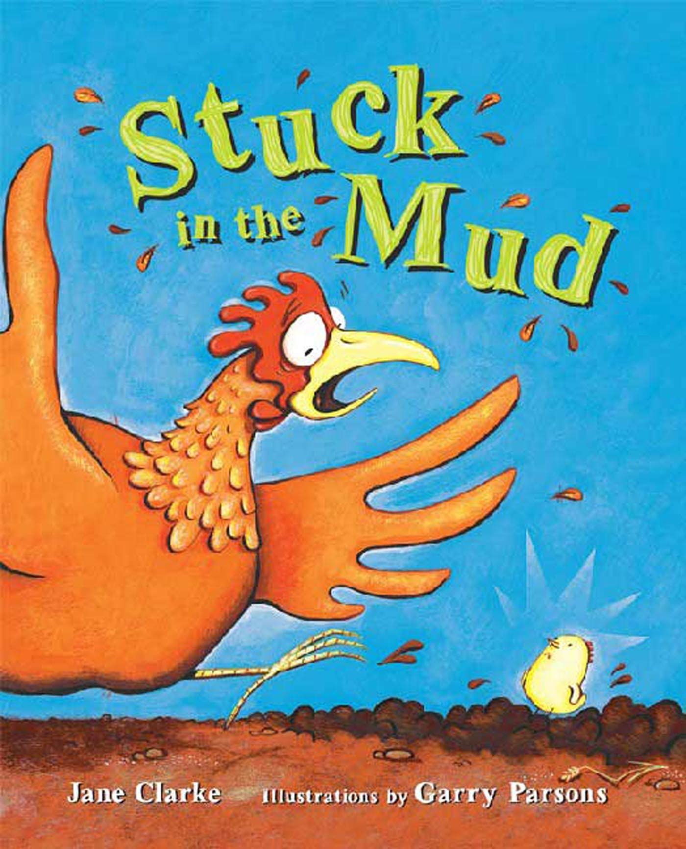 | 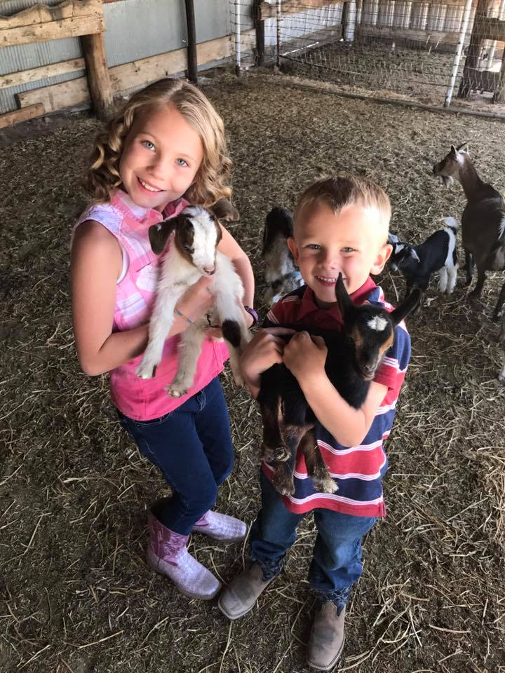  Free Admission for the families  Extended family (other relatives)  $8/per person  Under 4: Free

Enjoy story time, music, ASL Chant, meet Deaf/Hard-of-Hearing/Spoken English role models, one pumpkin per family  RSVP by October 5  RSVP LINK: bit.ly/PPELOct22  Questions: Contact JM at jmclellan@csdb.org  Co-Leads: Jennifer McLellan & Jill Cimino | 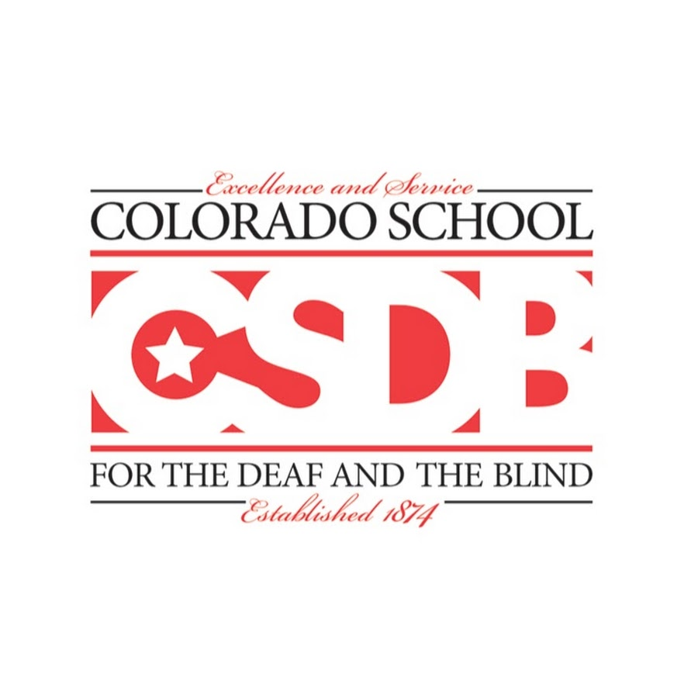

Colorado School for the Deaf and the Blind

33 N Institute St | Colorado Springs, CO 80903 | 719-578-2100 | www.csdb.org

