# CSDB Board of Trustees

# Superintendent’s Report

# April 2025

## STUDENT ENROLLMENT

### As of March 20, 2025

Total Number of Students Currently Served Statewide 693

Total Number of Students Served on Campus since August 2024 184

Current Campus 3-21 Enrollment 169

Students in the School for the Deaf:

Preschool 11

K-5th 19

6-8th 28

9-12th 27

Bridges to Life 10

Total 95

Students in the School for the Blind:

Preschool 3

K-5th 19

6th-8th ................................................................................................................................................. 14

9-12th 32

Bridges to Life 6

Total 74

Day Students 124

Residential Students 45

Parent Option 164

District Option 5

Teacher/Student Ratio 1:4

CHIP (Colorado Home Inclusion Program) (Deaf) 364

CHIP Referrals .................................................................................................................................. 9

CHIP (Deafblind) ............................................................................................................................. 13

Blind: Birth – 3 yrs. ......................................................................................................................... 35

Direct Outreach 88

ELDI (Early Literacy Development Initiative) Programs 96

ELDI Waiting List ............................................................................................................................19

## REPORTS FROM SUPPORT SERVICES

**Human Resources**

* Interviews to be held:
* Dining Services IV
* Admin III - HR Final Interviews
* Principal - School for the Blind
* State Teacher Aide (2 Vacancies) – School for the Blind
* Health Care Tech Blind/VI
* Health Care Tech Deaf
* Registrar / Program I – Student Services
* Transition TOD – BTL
* Vacancies currently posted and in progress to be posted:
* TVI K-6th
* TVI School for the Blind
* TVI Outreach
* TOD Secondary Math
* TOD Physical Education/Health
* TOD Secondary Science
* TOD Secondary ASL
* TOD Elementary
* School Psychologist / School for the Deaf
* State Teacher Aide / Preschool
* TOD PE Health
* Literacy Teacher Interventionist and Coach / School for the Blind
* Admin Assistant II – Dining Services
* Custodian III (Repost)
* TOD Secondary English Language Arts
* Open Enrollment is coming up in April. This year is passive for all benefit changes.

**Accounting**

Joint Budget Committee Update – Long Bill Introduction

On March 4, the figure setting session for the Department of Education was conducted amidst a statewide budget deficit of $1.2 billion. As a result, our Joint Budget Committee (JBC) analyst has recommended funding solely for the teacher salary increase of $65,958, consistent with D11 requirements per statute.

The introduction of the Long Bill, originally scheduled for March 24, has been postponed. The JBC Chair announced it will now be introduced on April 1. Due to this delay, the timeline for the final passage of the Long Bill may be affected. The original dates are March 28 in the Senate and April 4 in the House.

Supplemental Bill (Senate Bill 25-091) for Vehicle Lease Payments:

This supplemental bill includes appropriations for the Department of Education. Specifically, the Vehicle Lease Payments line item has been increased from $38,683 to $45,751, reflecting a $7,078 adjustment in this year’s budget, which will avoid the expenditure shortfall for this line-item.

Accounting / Food Service Personnel Update

Accounting Technician Position: We welcome Kellie Moothart as our new Accounting Technician. She is a parent of two students at our Deaf school, and we are excited to have her on board. The accounting team is now complete.

* Dining Service IV Position: Interviews for the second Dining Services IV position were held on March 21. We are pleased to announce that Catherine O’Keefe will be joining our kitchen staff on April 14.
* Administrative Assistant -Food Service Position: The position was posted internally on March 20 and will close on March 27. We anticipate filling this position within the next few weeks.

**Finance Reports:**

* The monthly finance reports indicate that expenses paid through February 28, 2025, are aligned with our budget projections for the remaining months of the school year.
  + A notable disbursement of $182,856 has been returned to the Office of School Safety. After discussions with the Office of School Safety Grants, it was determined that due to a lack of progress and no current plans to complete the project outlined in the grant award, returning these funds would allow them to assist another school / school district with their safety and security needs.
* An overview financial report of campus construction projects is provided for your review.
* The Joint Budget Committee analyst provided a tentative FY26 Base Appropriation report this week, which will be incorporated into the Long Bill. Notably, the previously allocated $100,000 one-time operating increase for kitchen steam kettle replacement and facilities equipment has been removed. Other adjustments remain consistent with the teacher salary increase, prior year salary survey, and prior year step pay.

FY2025 February Total Donations: $50

* + Colorado Alpha Delta Kappa: Donation of $50 for the Playground Project.

**Facilities**

* History Colorado is nominating our facilities to be included into the National Historical Registry (nomination due in May and Review Board decision in September)
* The Capital Development Committee supported West Hall Renovation & Addition project 6-0; Joint Budget Committee (JBC) decision next.
* Replace Water Main project and Elevator/Wheelchair Lift construction made Office of the State Architect (OSA) Level 1 funding request; Brown Hall Renovation Phase 1 made OSA’s Level 2 funding request.
* Security Upgrades
* Awarded Phase 2 Site Improvements
* Perimeter fence and pedestrian gates around the West side of the Gym to support public events in the Upper Gym
* Sidewalk from Stone to the South Gym parking lot and Pikes Peak w/fence & pedestrian gates (O&M/Accessibility Improvement)
* Sidewalk from Gym to Hancock (O&M/Accessibility Improvement)
* Dumpster relocation to support Sidewalk from Gym to Hancock
* Perimeter fence and pedestrian gates around the Industrial Plant
* Replace fence Southwest of Brown Hall
* Replace fire lane gate East of Stone
* Gym Renovation
* Due to elevator, lighting, door hardware delivery delays, schedule extended through the end of March.
* Completing heating & cooling upgrades throughout
* Upgrading LED lighting throughout
* Install Shot Clocks in Main Gym week of March 24th (Spring Break)
* Installing braille signage throughout
* Installing elevator
* Elevator Upgrade & Modernization
* Design in progress
* Elevators: Admin, Argo, Brown, Ritter
* Wheelchair Lifts: Stone and Adams (review/simplify Admin lift operations)
* Due to long elevator delivery times, construction planned for Summer 2026

## OUTREACH PROGRAMS

## Colorado Instructional Materials Center (CIMC)

**Statewide Student Registration Database & Federal Quota Census Count**

On March 15th, CIMC staff closed out both of our annual counts, (1) the statewide count, and (2) Phase I of the Federal Quota census count. From January through March, CIMC hosted one-on-one Zoom meetings with multiple administrative units, (AUs), their agency designated contact person(s), and TVIs to answer questions and update Phase I paperwork for their infant/student enrollment specific to the Monday, January 6, 2025, count day. CIMC was only able to enter new students into the federal census database during Phase 1 which ended on March 15th. Final registration database reports will be disseminated to each AU after Phase 3 of the federal quota census has closed.

**First Friday and Southern Region TVI/DVR Meetings**

The CIMC hosted their monthly “First Friday” statewide zoom meeting on March 7, 2025. CIMC staff answered questions from TVIs, paraprofessionals, school district braillists representing 18+ administrative units. Five of the attendees represent multiple administrative units. Topics included an overview of this year’s 2025 statewide count and federal quota census account; the annual April 1st braille textbook order deadline for school districts needed braille textbooks and novels for the next 25-26 school year (especially new braille transcriptions); and new APH products.

Tuesday, February 25, 2025, the Division of Vocational Rehabilitation (DVR) hosted the Southern Region TVI/DVR meeting in their offices in Colorado Springs. The following AUs attended: El Paso D20 (Air Academy), El Paso D49 (Falcon), Ute Pass BOCES, and CSDB Outreach (Maddee Durossette, Danielle Steele, Debbie Haberkorn, Jim Olson, Sara Noel). All local DVR staff presented services available including youth services (which start at age 15) and adult services, eligibility requirements, Pre-Employment Transition Services (Pre-ETS), ability statements, and the DVR services handbook. The CIMC will be hosting a Make-And-Take meeting on Tuesday, May 13th in Jones Hall (3rd floor).

American Sign Language Team

**Community ASL Classes:**

We began our six Community ASL classes and two ASL level classes for CSDB families on campus in Colorado Springs on January 14th and 16th. Unfortunately, snow days impacted all the classes in Colorado Springs. We made up two classes on Tuesdays, one on Thursday here in Colorado Springs, and one day in the Denver area in March. We had 94 attendees at CSDB and 49 attendees in Denver.

We sent out registration for virtual ASL classes on March 6th for CSDB families statewide, except for those who live in Colorado Springs, as they are encouraged to attend in-person classes.

**Immersion for Professionals:**

We sent out the flyer on March 11th. Our next session is scheduled for April 12th at the Lowry Conference Center in Denver. This will be the first time we are offering Immersion for Professional in the Denver area. We will offer three different levels in the morning from 8:00 AM to 12:00 PM and another three levels in the afternoon from 12:30 PM to 4:30 PM.

**Colorado Digital Learning Solutions (CDLS) - Online ASL Courses for Middle and High School Students**

Twenty online students are progressing through CDLS for the second semester of ASL classes. CDLS is an online program that provides Colorado districts, BOCES, and charter school access to high quality online courses.

**ASL Classes for CSDB Staff**

ASL classes for CSDB staff are in session. Since the NSLA and ASLPI assessments have been approved by the Board of Trustees and implemented in the policy, we are still waiting for Human Resources to give us the "go-ahead" to start scheduling staff to take them.

According to the GBF-E-1 policy, staff who work with blind students and CIMC staff will be required to take the Basic Emergency Communication Course. The ASL Team is offering two different days and times for staff to sign up. So far, we have had six staff members signed up, with 14 spaces left. We are hoping to have both classes filled before they start in the first week of April.

## Itinerant Services

The two dually certified Teachers of the Visually Impaired and Certified Orientation and Mobility Specialists in Outreach provided services to 31 students in five school districts/BOCES. The number of school age services has stayed consistent month to month due to caseloads being at maximum capacity. Outreach has not accepted any new contracts for vision or orientation/mobility services since September 2024. We have received requests for services that cannot be filled due to a vacant position and the provider’s caseloads being at capacity.

For early intervention, birth to age 2 years, the vision providers have 35 families on their caseloads and provided 46 visits to the 26 families receiving visits in January. Visits were not provided to six families due to family illness or families not responding to provider communication to schedule visits.

The two Outreach Teachers of the Deaf provided DHH services to 56 students from two school districts and seven charter schools across the state during February 2025.

## Early Education Team

**Little Language Learners**

The Little Language Learners in Northern Colorado continues to see strong excitement from families. March had 4 families attend. They focused on the theme of hide and seek.

The Little Language Learners of Pikes Peak spent the month of March learning about dinosaurs. They became archeologists digging for dinosaurs in rice and fossils in sand, dramatic play with a volcano, and created dinosaur hats. This month 1 student “graduated” (aged out), 3 continued enrollment, and 2 new enrollments. The current total enrolment for LLL-PP is 5 students.

**Little Learners and Explorers**

The Little Learners and Explorers program is in the works for coming back to the Pikes Peak area. Staff are collaborating and planning for students to join in the spring.

**CHIP Coordinators and Early Literacy Development Initiative**

**Colorado Home Inclusion Program (CHIP) Coordinators, along with the Early Literacy Development Team, continue to serve families all over the state. The end of February brought the opportunity to advocate for our families when we received the news of the $4 million dollar shortfall that Early Intervention Colorado was facing. We committed to providing information to families as we got updates. As of March 13, EI Colorado has sent notice that the Joint Budget Committee approved $2 million dollars, and local program contracts were renegotiated so that services for families and reimbursements for providers will remain unchanged for this year. This emergent notice prompted CSDB Outreach programs to start looking at data specifically related to early intervention services for children who are deaf/hard of hearing and blind/low vision. This data will be used to guide future programming decisions.**

**The Colorado Shared Reading Program is currently serving 96 families (20 birth to age three and 76 from ages three to eight). Additionally, CSRP is in the process of mentoring the new instructors, as well as looking at programmatic changes that can allow more families to have services and reduce the waiting list.**

**The Early Education Team presented at the Colorado Department of Education Teacher of the Deaf Monthly Meeting at the beginning of March. This was a fantastic opportunity to highlight the amazing work of this team and educate Teachers of the Deaf about CSDB Early Education programs!**

**The March Early Literacy Event was held at the Denver Children’s Museum and 108 families (415 people) attended! This is one of the most popular events because families that attend receive free family membership to the museum. Families enjoyed exploring the museum, ASL Storytime, and connecting with Deaf adults, professionals, and other families.**

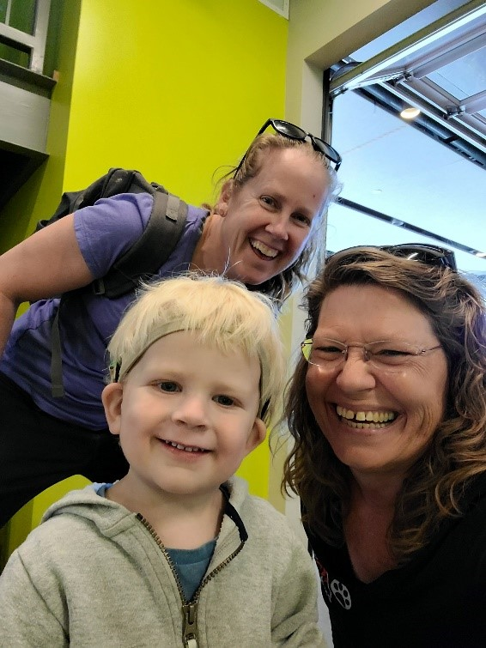

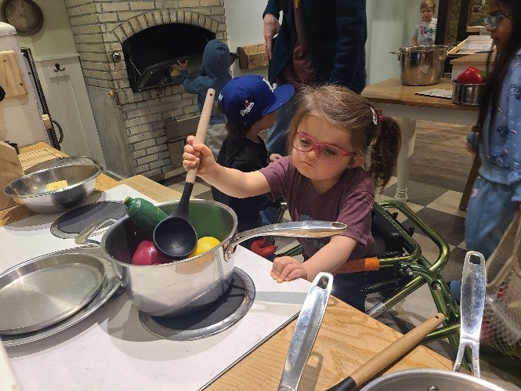

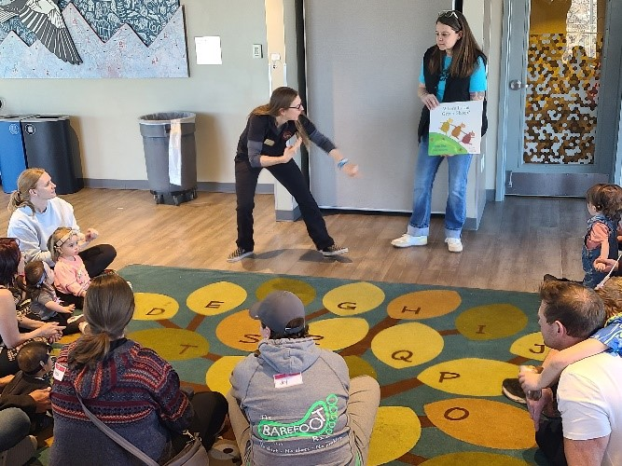

**Finally, Outreach Programs sent two staff to the Early Hearing Detection and Intervention Conference in Pittsburgh March 10-11. The Early Education Coordinator was part of a team of four that hosted a Roundtable Discussion and Networking Meeting prior to the start of the conference and presented on our work last year through a contract with Early Intervention Colorado to train evaluation entities how to use the state purchased Otoacoustic Emissions (OAE) devices.**

**Ascent Program**

The Ascent Program is funded through Hands and Voices with federal grant funds from the Early Hearing Detection and Intervention Program. Hands and Voices sent four Deaf/Hard of Hearing adults with Ascent to the Early Hearing Detection and Intervention conference in Pittsburgh March 10-11.

## **Early Education Center**

The EEC students invited families to participate in their St. Patrick’s Day Party. Seven adults and two siblings joined in the festivities. The March classroom themes are Bug and Spring/Gardening. Students explored the texture of dirt in the sensory bins, planted seedlings, and learned about spring ecosystems when building bird feeders.

## ALL SCHOOLS

### School for the Blind

* The CSDB Braille Challenge was held on February 24, 2025, with competitors in five categories, fun activities for “rookies,” and musical performances by three bands.

Ten competitors were awarded prizes and celebrated during announcements.

* Twenty-one secondary students are participating in a weekly music and theatre Fine Arts Center collaboration, co-coordinated by Allie Unker and Emma Reece.
* Six secondary students attended a ski trip to Crested Butte February 26-March 2, 2025, after conditioning in a new afterschool Ski Club, led by Aimee Twaddle.
* Elementary and secondary students participated in the Special Olympics basketball.
* Secondary students participated in information sessions about Bridges to Life, CSDB rebranding, and a new afterschool club focused on coding and technology.
* Staff received Deaf-Blind training from Jessica Meisel, DB TA Specialist with CDE.
* District assessments were completed March 3-21, 2025. State assessments, including CMAS, CoAlt, DLM, SAT, and PSAT, are scheduled for March 31-April 25, 2025.
* Jennifer Mathews was chosen as a School Librarian of the Year finalist by SLJ.

Link to article: <https://www.slj.com/story/jennifer-mathews-overcoming-obstacles-2025-school-librarian-of-the-year-finalist>. Congratulations, Ms. Mathews!

* All vacant positions (Principal; Literacy Teacher, Interventionist, and Coach; Elementary TVI (K-6); and 2 State Teacher Aides) are posted and conducting interviews.
* The Beeping Egg Hunt is scheduled for April 17, 2025, 9:30-11:30 AM.
* The Blind Advisory Committee is currently planning a Blind and Low Vision Career Fair for secondary and Bridges to Life students on Friday, May 9, 2025.

**BtL**

* The Colorado Center for the Blind will be visiting in April to talk to our students about the job interview process and knowing when to disclose their disability in the interview process.
* Juniors and Seniors from the School for the Deaf and the School for the Blind participated in information sessions about the Bridges to Life program.
* One of our BtL students is participating in job shadowing experiences at the Cheyanne Mountain Zoo gift show and the National Mill Dog rescue.
* On April 17th at 5pm, the Bridges to Life program will have a table at the 2025 Annual Resource Fair for Individuals with Disabilities at the Hillside Community Center.

### School for the Deaf

* On March 17th, our elementary students (Kindergarten to fifth grade), participated in various St. Patrick's Day activities. Students completed a packet with reading, writing and mathematical concepts (such as addition and subtraction to 100, descriptive writing about leprechauns, sentence corrections, greater than/less than review, etc. Students were also able to participate in an exciting scavenger hunt, leading them to the pot of gold! Students read clues and followed them until they were able to find the gold. Students also enjoyed a "lucky charms" graphing activity in which they sorted their lucky charms and documented the data on a bar graph before answering questions. Overall, it was a fun and educational day!
* In High School math classes, students learned to transform shapes by the means of rotation and dilation. They further mastered their skills with translations and reflections. Students in another math class calculated the square of integers and continued their work on the Pythagorean Theorem. Other students learned to calculate the gain they could make from depositing money into savings accounts in their banks. They completed their work calculating their net income after payment of car loan and house mortgage.
* Students in World History reviewed the information in the text about Hatshepsut, Great Royal Wife of Pharaoh Thutmose II and the sixth pharaoh of the Eighteenth Dynasty of Egypt. They worked as a class to make a list of her accomplishments on a poster. A general obituary was shared with students so they could point out which things in the list might be in Hatshepsut's obituary.
* The 4th/5th grade class learned about primary and secondary sources for history. They completed a history project where they researched an important historical figure and had to use both primary and secondary sources for their research.
* There are artists from the FAC that come and teach wonderful things to our middle and high school art classes. We have a clay artist, a fiber artist and a performance artist! The performance artist is teaching my drama students how to tap dance, and we are working on an expressive ASL dance as well that will be performed at the FAC in May. Recently, our Outreach department asked if there could be a showcase of artwork by our students at the ASL festival in April. We are also underway with getting De'VIA artwork ready to be submitted again to the De'VIA art contest.
* High School English Language Arts classes started researching William Shakespeare and his background as they will start reading Romeo and Juliet.
* Students in U.S. History work with a partner to develop a list of the economic, military, and cultural characteristics of the United States in the last half of the 1800s. Each pair identifies one characteristic from its list that it thinks most influenced U.S. imperialism during that time and writes a paragraph defending its choice. Students read aloud their paragraphs.

## STUDENT LIFE

**Athletics**

* Special Olympics Basketball End of Season Party in the BAC on March 17th
* Track and Field starts March 31st. Middle School, High School and Special Olympics

**Afterschool programs**

* Block 4 schedule published.
  + Outdoor Adventures Deaf Elementary
  + MS/HS Coding club, put on by our own IT department.
  + Weightlifting in the fitness center
  + Walking Club-Blind 3:30-4pm Tuesday’s and Thursday’s
  + Open Gym for Dorm students only

**Dorm activities**

* + YMCA Swimming
  + Bear Creek Nature Center Walk
  + Weightroom workouts
  + St. Patrick’s Day Party (Dorm only)
  + Building Positive Peers workshop
  + Bikes on Campus
  + Red Rock Canyon Open Space Hiking Trip
  + On the Border Mexican Grill off campus dinner
  + Open Caption Movie Night off campus Movie theater
  + Manitou Springs tasting five different mineral natural spring waters.
  + Library 21C off campus trip
  + Ice Skating Airforce Academy Cadet Skating Rink
  + Arts and crafts
  + Springs Adventure Park rotation with different dorms. (Trampoline Park)

**Residential Overview**

* We have 3 vacancies in the residential program currently interviewing this month for HCT1 serving blind/visually impaired. Deaf HCT1 interviews will be scheduled in April.
  + 1 vacancy working with students who are Deaf and Hard of Hearing
  + 2 vacancies working with students who are blind or visually impaired.
  + We have subs filling the vacant positions currently.
* Our enrollment numbers as of February 18th, 2025, are as follows:
  + 10 BtL students
  + 5 middle school students
  + 3 elementary students
  + 9 Deaf HS Boys
  + 7 Deaf HS Girls
  + 10 Blind HS mix of girls and boys
  + 1 Blind Middle school students.
* Supporting school for the Blind in after school assistive technology trainings 3 days a week.

## COMMUNICATIONS

Media

* School Library Journal [“Jennifer Mathews: Turning Challenge into Opportunity”](https://www.slj.com/story/jennifer-mathews-overcoming-obstacles-2025-school-librarian-of-the-year-finalist) Published March 18
* Colorado Department of Education Facebook page (12k followers) “[Teacher Tuesday”](https://www.facebook.com/share/p/1APb2T943e/) Recognizing our Deaf school teacher Aly Cottrell for outstanding work. Posted on March 4
* Deaf Women United Facebook page (16k followers) “[Deaf Women Herstory](https://www.facebook.com/share/p/1CxhP1ARjv/)” Spotlight” Recognizing Taiyabah Naeem. Posted on March 10

Videos produced for Social Media (Facebook, Instagram, and YouTube)

* Braille Challenge recap (3.4k views)
* Academic Bowl recap (9.3k views)
* Blind Ski Club trips (3.3k views)
* March Superintendent Message (2.6k views)
* Rebrand Session Event Details (4.5k views)

Website Data (csdb.org) – March 1 – March 19

* Total views: 17,508 views (15.9 % decrease compared to previous month)

Social Media – Feb. 17 – March 18

* Facebook

Accounts reached: 46.3K (30% decrease than previous month)

Total views: 175k (30% decrease)

* Instagram

Accounts reached: 5.6k (93% decrease than previous month)

Total views: 23.6k (87% decrease)