VIRTUAL
EARLY LITERACY EVENT
Wed, October 5, 2022
10-10:30 AM
(birth to age 3)
(age 3-5)
Join us for our virtual event for children who are Deaf or Hard of Hearing, from birth to age 5, and their families

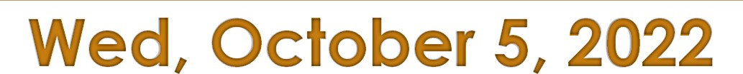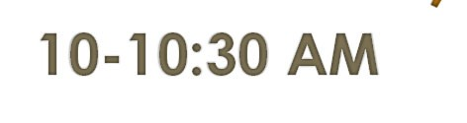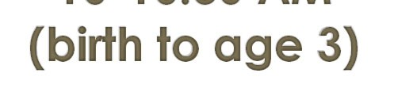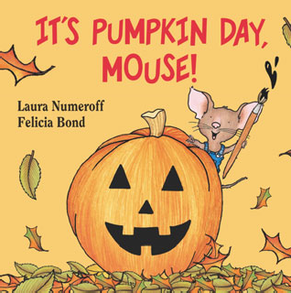
VIA ZOOM

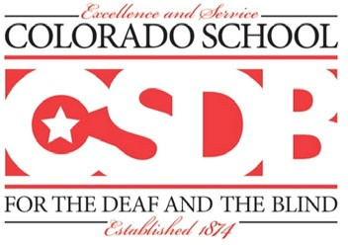
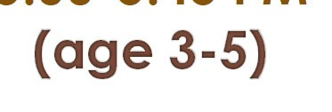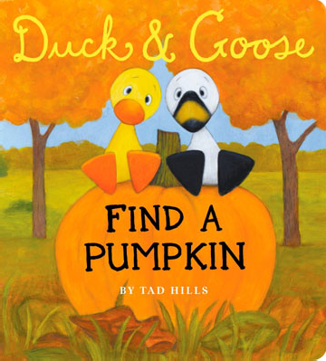Enjoy story time, ASL chant, music and movement, follow up activities, and access to ASL and Spoken Language
5:00-5:45 PM
RSVP by October 4 (will share Zoom link after RSVP) RSVP LINK: https://bit.ly/ELEOctoberPumpkin Contact: Kim kparra@csdb.org
Co-Leads: Kim Parra and Elaine Kim McCarty

Colorado School for the Deaf and the Blind
33 N Institute St | Colorado Springs, CO 80903 | 719-578-2100 | www.csdb.org

